

**TECHNICAL AND BUSINESS WRITING**

**Assignment 1**

**Group Members**

Danish Abdullah 17K-3720 Section D

Murtaza 17K-3886 Section D

Mustafa Manga 17K-3795 Section D

Huzaifa Abid 17K-3807 Section D

**Ergonomic Chairs – A Useful Investment**

**Background**

Ergonomics is defined as the scientific study which deals with improving the common workplace issues and its effectiveness. Ergonomists observe people, their behaviors and how they interact with their work environment and then they work with designers to find the solution of the problems being faced by people. Their seating issues are resolved by designing an ergonomic chair which takes all these principles into account to create a comfortable working environment [1, 3].

**Definition**

Ergonomic is defined as the scientific study of people's psychology and their work environment to enhance the efficiency and effectiveness in their working environment [1].Chair should have minimum requirements like adjustability, seat depth and lumber support to be considered as an ergonomic chair [1].Ergonomic chair is designed by understanding the psychological and physiological needs of the user. After the psychological and physiological study, the biomechanics and engineering are applied to produce an ergonomic chair [2]. It has customization for different features such as seat adjustability, levers for adjustments/alignment and armrests [2]. Long sitting hours can induce back pain, neck pain and lumbar distress due to the natural tendency to lean forward. An ergonomic chair offers a solution, for all the pain and stress, by having adjustable seat, backrest and many other features. This means that you can adjust the seat of your chair according to your height, spine and workstation [2].It helps in many workstations for workers to work in efficient and effective manner [3].

**Purpose**

Office workers usually spend long hours sitting at work which makes them slouch forward; this puts stress and pressure on the back and eventually becomes painful; therefore, to avoid this it is important to have an office chair that is ergonomic. An ergonomic chair provides comfort to the back and fits the body of the worker [1, 5]. It also helps you maintain a good working posture and avoid back pains to help become more productive throughout your working day [3]. Ergonomic chairs are designed to prevent work related injuries and to maintain the overall health of the employees. The more comfortable the employee is, the more productive he will be [6].

**Features**

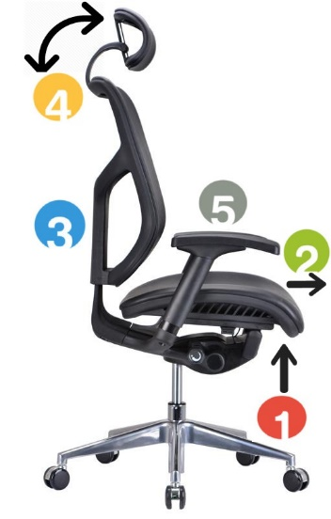What makes ergonomic chair important and differentiates it from other chairs are the features an ergonomic chair possesses. Following are the features of an ergonomic chair [2]:

1. **Seat Height**

Different people have different heights. A user of an ergonomic chair is able to adjust the seat height such that the user’s feet are placed flatly on the floor.

1. **Seat width and depth**

A few inches gap between the edge of the seat and the back of user’s knee to provide proper comfort. If the edge is too forward, it might put pressure at the back of the knee resulting in distress.

1. **Backrest Support**

To support the natural ‘S’ shape of the spine, an ergonomic chair allows its user to adjust the backrest and align the curve in the chair with the curve in their spine for an optimal lumbar support.

1. **Headrest**

To reduce the tension from the shoulders and upper torso, an ergonomic chair provides a headrest. It is really important for the correct posture of the neck.

1. **Armrests**

Armrests help to reduce the tension in upper body and to relax shoulder from aching.

**Benefits**

Some of the benefits of ergonomic chair are listed below:

1. **Improved Worker Health**

74% of the workers who sit at their desks experience back pain which leads to health issue and leave from work. Ergonomic chairs are designed to prevent back pain by supporting the spine and maintaining natural body posture. It prevents arthritis and other work related injuries. Workers’ health is not only physical, it is also mental and if you invest in ergonomic chairs the employees will feel that their employer cares for them and respects them and in return they will work more happily and effectively [4, 6].

1. **Better Work Productivity**

Ergonomic chairs helps reduce stress which makes the workers more focused which in turn results to better productivity. By reducing distractions, it helps workers make better decision and make fewer mistakes. As there are fewer injuries, there will be fewer sick leaves and workers will perform better and spend more time in the office [4, 6].

1. **Customizability**

As an office can have shifts and multiple employees may need to use the same desk; therefore, they will need a chair that fits them too. An Ergonomic chair is customizable to fit everyone. It has levers to adjust the height, arm rest, head rest, back etc. and it provides adequate seat width and depth to fit everyone [4].

1. **Reduced Business Costs**

Sitting in normal chairs for longer durations can cause musculoskeletal disorders, which currently costs America $50 billion annually. Employers have to pay between $15 and $18 billion to compensate them for these work related injuries. Ergonomic chairs proactively prevent these expenses by providing a comfortable seating arrangement which helps them focus and prevents work related injuries and diseases. It is a major cost cutter for businesses around the world [6].

**Testimonies**

The testimonies of Company’s managers using an ergonomic chair in their company’s office portray the importance, benefits and need of an ergonomic chair. Few testimonies are as follows:

Manager at ABS: “We are using ergonomic chairs. Initially, the costs were a big concern, but now I feel it was a good investment. Our employees are more comfortable and relaxed and enjoy their work. They are healthier and happier and don’t mind to work extra hours.” [7]

“Yes, as regulation by Employee Benefits Authority at our company, we had to install ergonomic chairs. The results are very good. Our employees feel more valued and love working more. They also take fewer breaks now to stretch and stroll to relax from sitting all day long. They are more efficient now.” said the Manager of KCS [7].